- The below screen will pop up after clicking the registration link. Please fill in your name, last name, and e-mail; tick the box that reads “I’m not a robot” and click the “Join Meeting…” or “Register” button

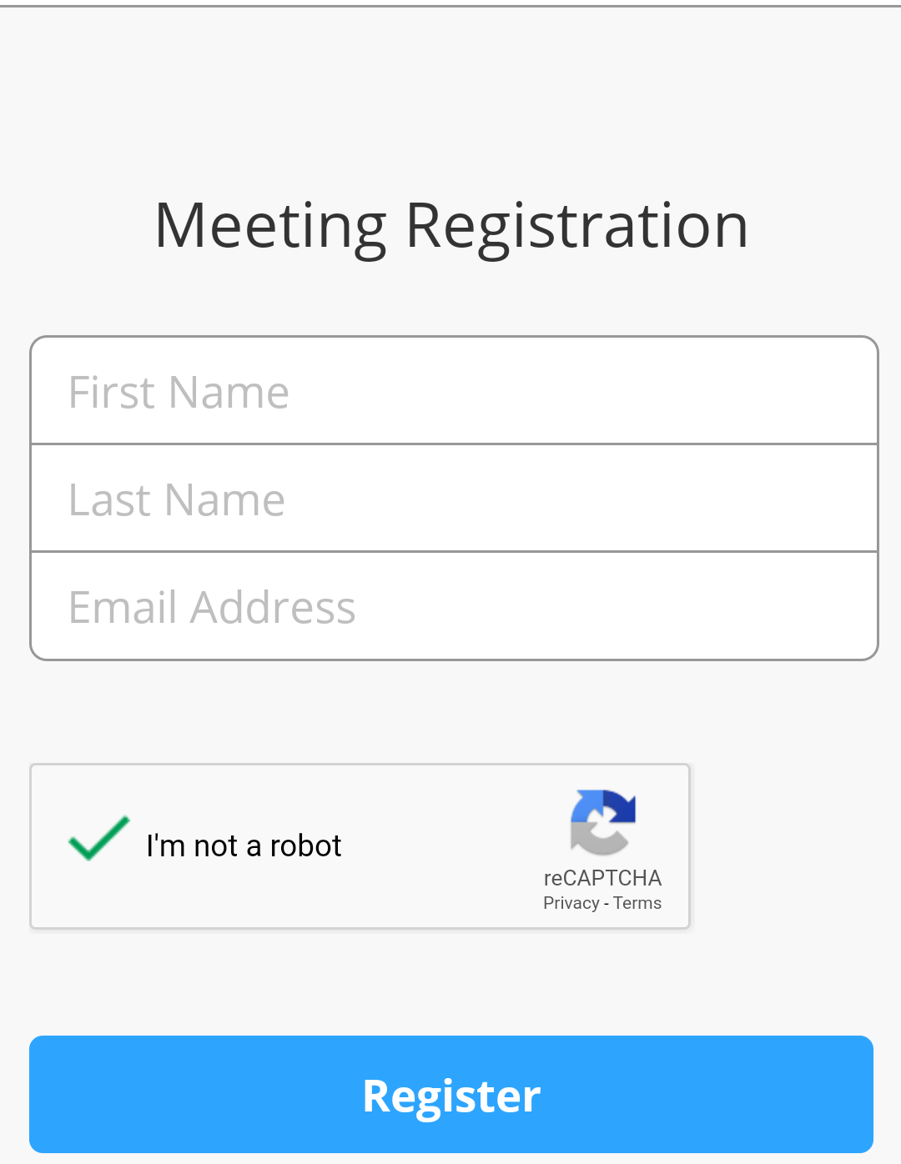

- You will receive an email with the invitation link after registering for the webinar. You can join the webinar by clicking the link in the email.
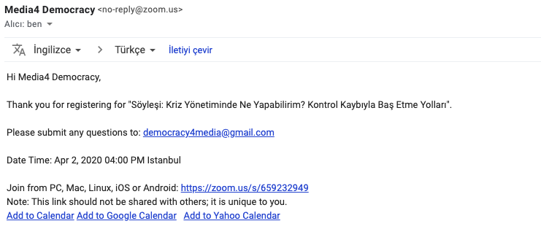
- If you have already downloaded the Zoom application, a screen will pop up that reads “Join Meeting” after clicking the invitation link. If you will download the application for the first time, click the “Download from” Google Play (for Android devices) or AppStore (for Apple devices)

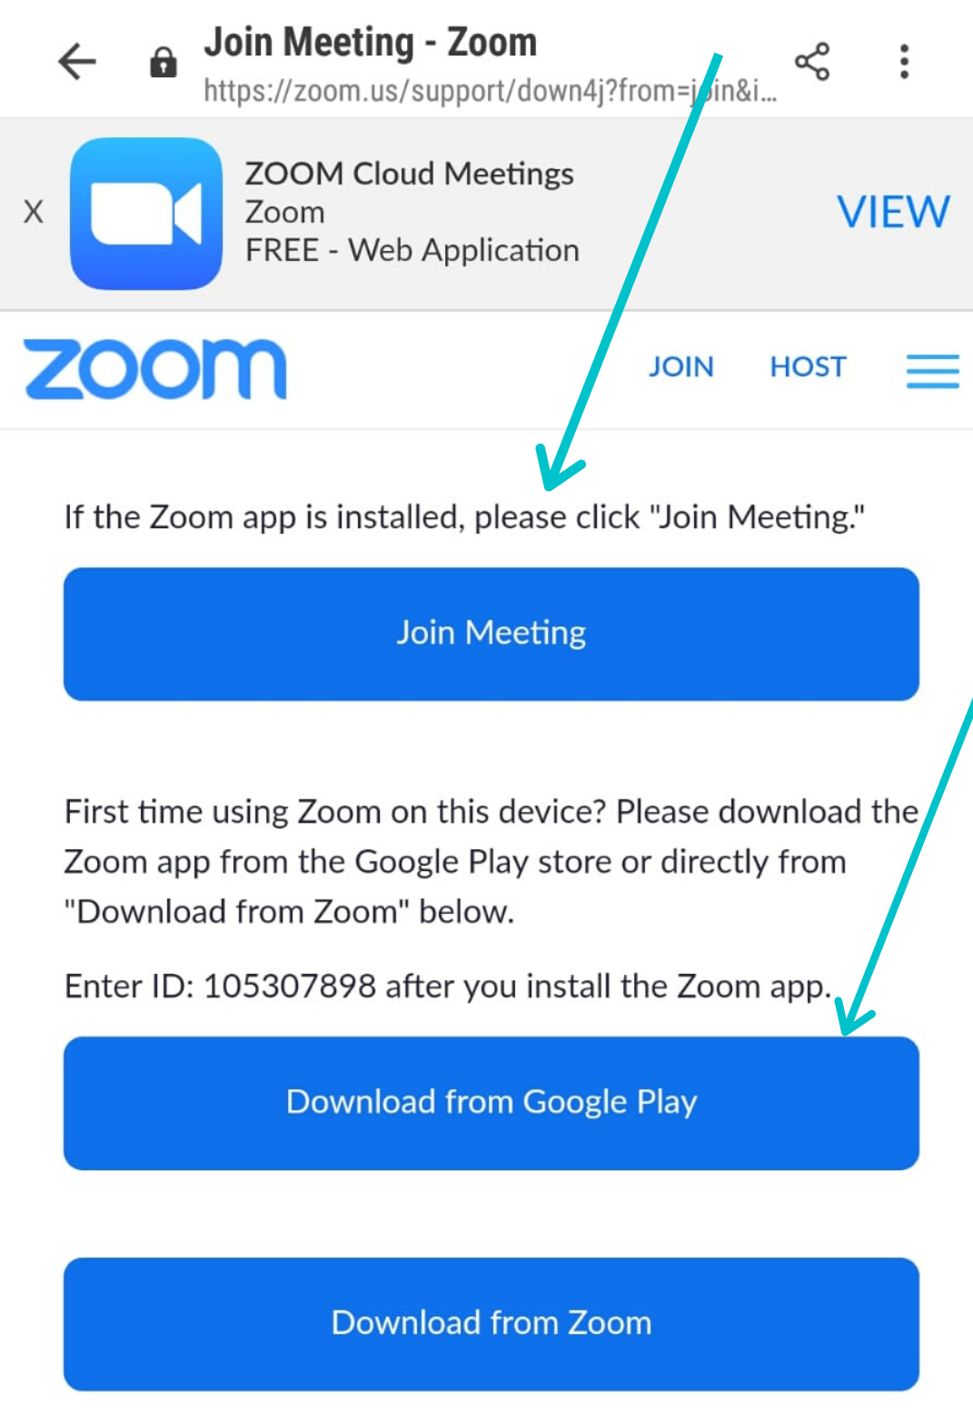

After you download or launch the Zoom application, you need to click again the link sent to you by e-mail or click the “Join a Meeting” option that pops up on the screen and enter the code 846 9396 5769.
(At the beginning of the meeting, you will see a window that says you will have to wait for a while before joining in the meeting. You do not need to do anything while you see this window. Your window will be activated automatically once the meeting begins).

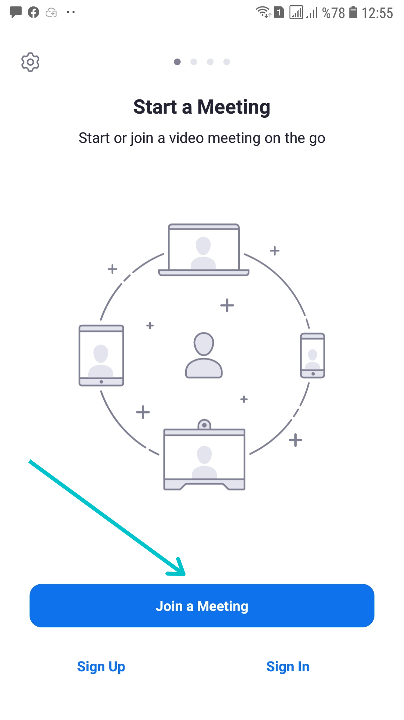
- Please wait once you follow the above listed steps and join in the meeting.

