- The below screen will pop up after clicking the registration link. Please fill in your name, last name, and e-mail; tick the box that reads “I’m not a robot” and click the “Join Meeting…” or “Register” button.

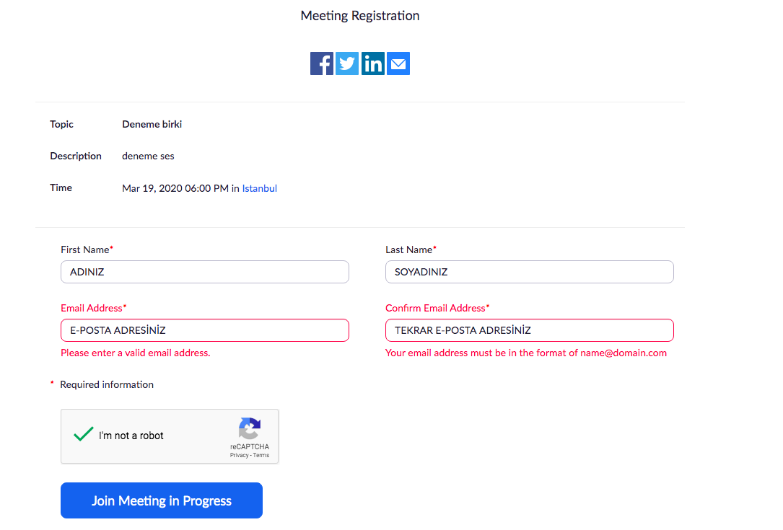

- After registering for the webinar, you will receive an email with the invitation link. You can join the webinar by clicking the link in the email.

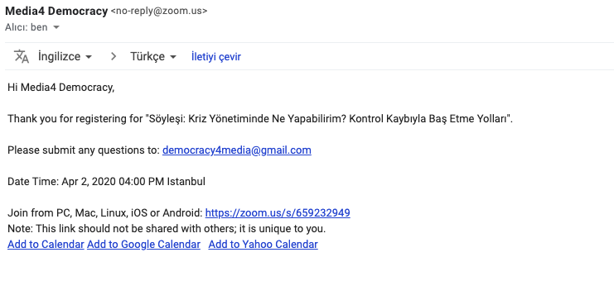

- After clicking the link to join the meeting, you will see “Join Meeting” on the Zoom window if you have already downloaded the Zoom application. If you will download the application for the first time, please click “open zoom.us”.

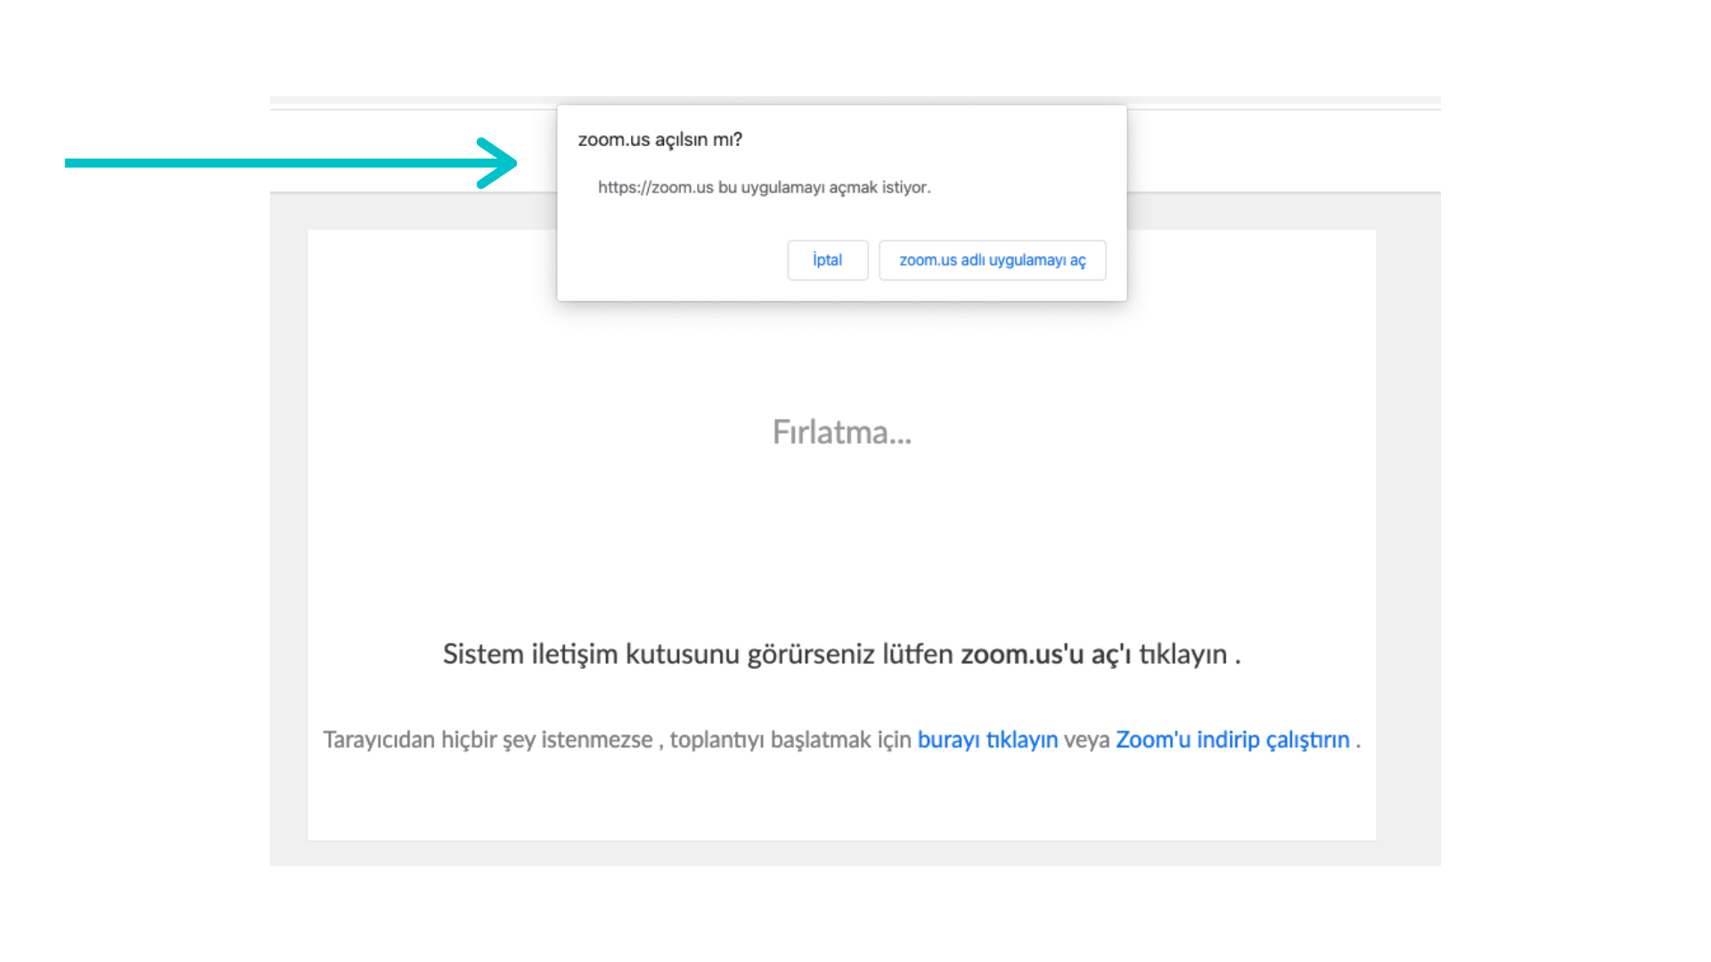

Once you download or launch the Zoom application, your computer will automatically direct you to the meeting. In case you are not automatically directed to the meeting, please click again the link sent to you by email or click the “Join a Meeting” option that pops up on the screen and enter the code 846 9396 5769. (You will see a window that says you will have to wait for a while before joining in the meeting. You do not have to do anything while you see this window. Your window will be automatically activated once the meeting begins.)

- Please wait once you follow the above listed steps and join in the meeting.

